**Chemistry IA3**

**Can we really ditch fossil fuels?**

**Claim:** Petroleum is and always will be the best fuel

**Rationale:**

To produce energy from a fuel, a combustion reaction is required with oxygen to produce heat and another product. The general formula for a combustion reaction is: Fuel + O2 → CO2 + H2O (Flexbooks.org, 2020). For worldwide energy production, currently 70% of all energy comes from non-renewable hydrocarbons. Hydrocarbons such as oil derivatives and coal have proven to be efficient and reliable sources of fuel, with the success of many developing third world countries being the easy access to advance, cheap fuel technologies (Transport vehicles, tractors, motors, etc) and apparent abundance of cheap fuel. While developing countries are using these easily available resources to build their economies, many first world nations, such as Australia, United States, United Kingdom, France, and many more that have stable economies have started to focus on preventing the damage caused by centuries of reliance on fossil fuels. Fossil fuel is the general term for any non-renewable hydrocarbon source, such as petroleum/gasoline which are oil derived, or coal. It is during the collection/ manufacturing/ refining and the eventual combustion of these finite fuel sources that toxic greenhouse gas emissions are created.

Energy production and consumption are currently the absolute worst sector in terms of greenhouse gas emissions (Ourworldindata.org, 2020). Greenhouse gasses are Carbon dioxide , Methane , Nitrous oxide , and sulphur hexafluoride (EPA.gov, 2023). These toxic gasses are the reason why global climate change is occurring. These gasses create an effect known as the ‘Greenhouse effect’ in which radiation from the sun enters Earths atmosphere before reflecting off the crust and hitting the outer atmosphere filled with these toxic gasses, which act as a blanket preventing the radiation from leaving the atmosphere. This trapped radiation begins to bounce back and forth between the outer atmosphere and the crust, causing an ever-increasing heating effect to the Earth’s surface, working similar to a garden greenhouse and thus the name. The increase in the percentage of carbon dioxide in the world’s atmosphere leads to climate change, and the rising global surface temperature in turn lead to an increased frequency and amplitude of natural disasters. The longer we pollute the air with unnatural amounts of carbon dioxide, the closer to the ‘turning point’ humanity reaches (RMetS.com, 2021). The turning point is an estimated point where the compounding heat becomes irreversible and permanent damage to fragile ecosystems occurs. In a bid to stop this, many first world nations have introduced laws to limit the amount of carbon they emit, in an attempt to safely transfer from a non-renewable grid and energy system to sufficient and cost-effective renewable system. Many first world nations have declared fossil fuels unfit for long term sustainable energy production, and in turn have started looking at cost effective and viable renewable alternatives such as biofuels.

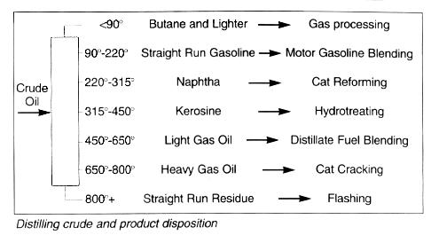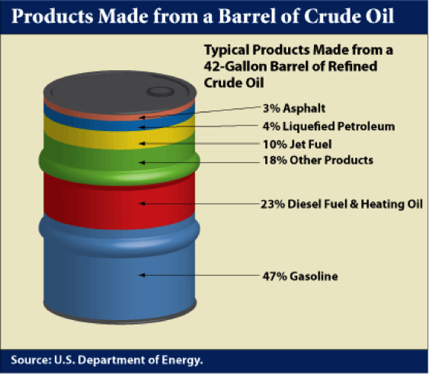

Figure 2

Figure 1

The worlds current dominant fuel source for automobiles is oil derived such as petrol and diesel. As shown in Figure 2, crude oil is refined through a long complex process of distillation, reforming, cracking, alkylation, isomerisation, polymerisation, and hydrotreating. This long process turns a barrel of crude oil into 47% petroleum, 23% diesel, and the rest to by **productions** such as jet fuel and petrochemical polymers (Figure 1). There are currently approximately 700 oil refineries worldwide that produce the world’s supply of petroleum-based fuels.

Biofuel is the general term for any renewable fuel source (Energy.gov, 2023). The most common biofuels used for motor vehicles are ethanol and bio-diesel. Ethanol is an alcoholic organic compound that is most commonly produced from the fermentation of sugars and starch sourced from sugar cane and corn. In Australia, the most common use of ethanol is in E10 fuel, which is a combination of 90% petrol and 10% ethanol. E10 is currently the most popular as it has the highest possible ethanol percentage that the majority of existing combustions engines can safely and efficiently handle. Other ethanol infused fuels include E85 which is between 70-85% ethanol with the rest being petrol. Unlike E10, E85 can only be used in a small amount of specific engines due being mostly ethanol. Unlike petrol, which requires specific growth of crops for ethanol production, biodiesel can be produced from waste oils and fatty acids. Through the process of transesterification, used cooking oils and fatty acids can be blended with regular diesel like petrol to reduce carbon emissions.

**Research Question:**

Do biofuels generate less greenhouse gas emissions during the manufacturing process compared to petroleum-based fuel sources, and is the energy they provide comparable.

**Discussion of evidence:**

Many government sources claim that biofuels are the only viable solution to solving the climate crisis and global carbon emissions (Epa.gov, 2023). Biofuels are regarded highly as they have the ability to use existing technologies (Almost all modern engines) without requiring extensive internal modifications. Other innovative technologies such as electric cars have also become mainstream within the past 10 years, but have faced issues such as the world not physically having enough minerals to replace all exists vehicles with electric ones. While hydrogen cars are also getting some light of day, they will need more time to simply evolve and have their technology researched, and not to mention the enormous cost to setup and maintain and entirely new fuel distribution system across the world. This in turns leaves biofueled cars as the clear leader for current technology.

Another topic for debate is the energy produced by ethanol and petrol. Comparatively, pure ethanol produces 30% less energy which equates to 3% less energy within the standard E10 fuel mix. For consumers, the general cost of E10 is normally equivalent to standard unleaded petrol (afdc.gov, 2023). This had led to many consumers to speculate the usage of ethanol, as they have to pay more to drive the same distance for a small amount of environmental savings. The energy per litre becomes worse with the higher ethanol content. To reduce carbon emissions using ethanol, the vast majority of cars would need to switched for newer ones to use higher and higher ethanol contents to in turn burn less petrol. But the higher the ethanol, the less energy is produced, for instance E85 has 27% energy than standard petrol, leading to an even worse fuel economy and cost on consumers, not to mention that currently, E85 can only be used in purpose-built engines (afdc.gov, 2023).

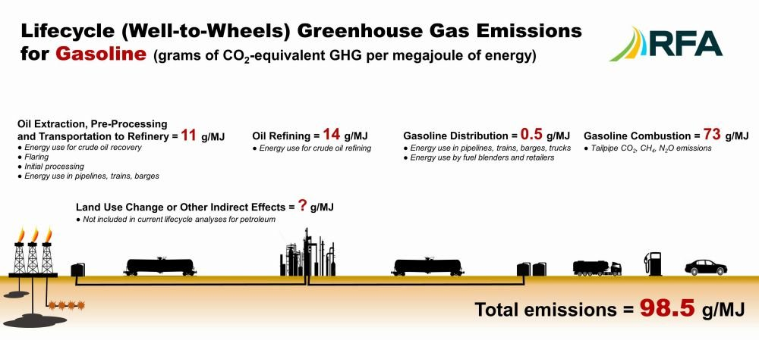Many sources claim that ethanol is completely carbon neutral. However, these studies fail to include the indirect emissions caused during the growth of the feedstock for ethanol production. Most ethanol feedstock crops, such as sugarcane, corn, and grains require extensive use of large machinery and farm equipment, also not including the large amount of petrochemical based fertilisers which themselves are by-products of petroleum refinery process. While not entirely carbon neutral, researchers have found that the overall carbon emissions produced by ethanol is almost half that of standard fuel.

Figure 3

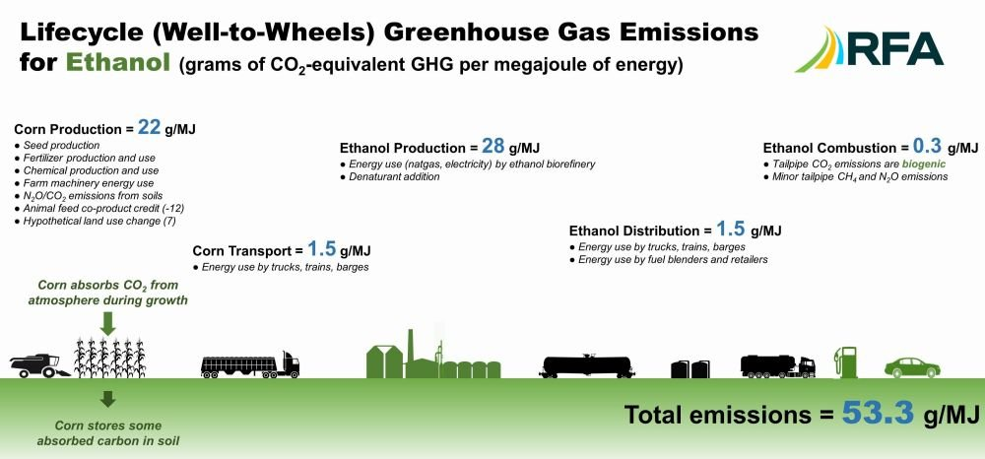It is shown above in Figure 3 & 4 that the majority of carbon emissions during the current ethanol production come from growth of feedstock and from the starch fermentation process. Throughout past debates, news outlets have used data cherry picking to compare the oil refining process in Figure 3 to the corn production process in Figure 4 in a bid to spread misinformation that ethanol was worse for the environment than standard diesel. It can be clearly seen above that total lifecycle emissions for standard petrol are 98.5g/MJ while ethanol emissions are almost half at 53.3g/ML.

Figure 4

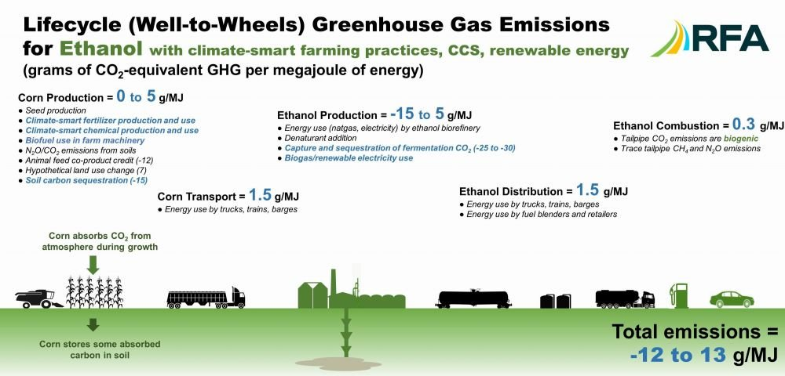

Figure 5

Furthermore, improvements in farming techniques can result in even further carbon emissions reductions. Using green agriculture techniques can reduce the corn production process as shown in Figure 5. Figure 5 also shows that it may not be entirely possible to reduce carbon emissions, but still highlights that ethanol is a much more sustainable long-term solution in regards to carbon emissions, emitting between -12013 g/ML of carbon dioxide.

**Conclusion:**

Therefore, throughout this research investigation it can be conclude that ethanol is a reliable, efficient, and cost-effective long-term solution to reducing global carbon emissions. While both feedstock and crude oil have long complicated processes to be turned into there respective fuel sources, Figure 5 represents how the ethanol production process can become environmentally friendly and carbon neutral. The uncertainty in Figure 5 also determines that there is still room for improvement, with modern agriculture sciences advancing, there are always new techniques being developed. These future techniques are being used to reduce carbon emissions during all stages of the ethanol production process. Inconclusion, it can be determined that with further research into biofuels, specifically ethanol, the manufacturing process can be improved to further reduce carbon emissions and support the earth’s environment.

**References:**

<https://forestplanet.wordpress.com/2012/08/16/six-good-things-about-petrol/>

<https://pei.org/wiki_pei/petroleum/#:~:text=Due%20to%20its%20high%20energy,energy%20since%20the%20mid%2D1950s>.

<https://energyeducation.ca/encyclopedia/Oil#:~:text=Oil%20is%20particularly%20useful%20as,creates%20crude%20oil%20over%20time>.

<https://flexbooks.ck12.org/cbook/ck-12-middle-school-physical-science-flexbook-2.0/section/5.22/primary/lesson/combustion-reactions-ms-ps/>

<https://www.un.org/en/climatechange/what-is-climate-change>

<https://www.e-education.psu.edu/fsc432/content/overview-refinery-products-and-processes>

<https://hrcak.srce.hr/file/65010#:~:text=There%20are%20about%20700%20oil,all%20parts%20of%20the%20world>.

<https://www.dcceew.gov.au/environment/protection/npi/substances/fact-sheets/ethanol-ethyl-alcohol>

<https://www.c2es.org/content/renewable-energy/>

<https://www.epa.gov/ghgemissions/global-greenhouse-gas-emissions-data>

<https://ourworldindata.org/emissions-by-sector>

<https://www.cleanenergyregulator.gov.au/NGER/About-the-National-Greenhouse-and-Energy-Reporting-scheme/Greenhouse-gases-and-energy#:~:text=The%20greenhouse%20gases%20that%20are,of%20hydro%20fluorocarbons%20and%20perfluorocarbons>.

<https://www.aip.com.au/resources/refining-petroleum>

<https://www.eia.gov/energyexplained/biofuels/ethanol.php>

<https://afdc.energy.gov/fuels/biodiesel_production.html>

<https://afdc.energy.gov/fuels/ethanol_fuel_basics.html>

<https://www.drive.com.au/caradvice/ethanol-versus-petrol-the-basics/>

<https://afdc.energy.gov/fuels/ethanol_benefits.html>

<https://rmets.onlinelibrary.wiley.com/doi/10.1002/wea.4058>

<https://www.energy.gov/eere/bioenergy/biofuel-basics>

<https://www.epa.gov/environmental-economics/economics-biofuels>

<https://www.sciencedirect.com/science/article/abs/pii/S0308521X16308563>

<https://ethanolrfa.org/media-and-news/category/blog/article/2022/10/the-truth-about-ethanol-and-carbon-emissions>

fortiain. (2012, August 16). Six good things about petrol. Forest Planet. <https://forestplanet.wordpress.com/2012/08/16/six-good-things-about-petrol>

tavo. (n.d.). Petroleum. Petroleum Equipment Institute. <https://pei.org/wiki_pei/petroleum/#:~:text=Due%20to%20its%20high%20energy>

Oil - Energy Education. (n.d.). Energyeducation.ca. <https://energyeducation.ca/encyclopedia/Oil#:~:text=Oil%20is%20particularly%20useful%20as>

CK-12. (2020, October 5). CK12-Foundation. Flexbooks.ck12.org. <https://flexbooks.ck12.org/cbook/ck-12-middle-school-physical-science-flexbook-2.0/section/5.22/primary/lesson/combustion-reactions-ms-ps/>

United Nations. (2022). What is Climate Change? Climate Action; United Nations. <https://www.un.org/en/climatechange/what-is-climate-change>

An Overview of Refinery Products and Processes | FSC 432: Petroleum Refining. (n.d.). Www.e-Education.psu.edu. <https://www.e-education.psu.edu/fsc432/content/overview-refinery-products-and-processes>